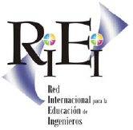 | X Seminario Internacional RIEI  “Educación de Ingenieros:  Ciencia, Tecnología, Medio Ambiente y Sociedad”  Mérida, Yucatán, México  10-13 septiembre, 2014

Theme: Engineering education: scientific-basic, society humanistic

Lecture: Elective course: Introduction to Arduino microcontroller

Presented by:
Roberto Brauer Di Renna – robertobrauer@telecom.uff.br
Thiago Elias Bitencourt Cunha – thiagobitencourt@id.uff.br
Alexandre Santos de la Vega – delavega@telecom.uff.br

Institution
Universidade Federal Fluminense (UFF), Escola de Engenharia, Niterói, Rio de Janeiro, Brasil, +55 (21) 2629-5606, http://www.telecom.uff.br/pet, pet@telecom.uff.br

ABSTRACT
This work aims to present the study, development and results of the elective course offered during the first period of 2014 named Tópicos Especiais em Eletrônica II (Special Topics of Eletronics II) ministered by PET-Tele group at Universidade Federal Fluminense (UFF). The project consisted in teaching electronics and programming for microcontrollers based on the Arduino development platform for the students of the first period of Telecommunications Engineering undergraduate course of UFF.

Keywords: education, undergraduate course influence, Programa de Educação Tutorial (PET), Arduino, microcontrollers.

- Introduction
There were several motivations for the development of this work. The Programa de Educação Tutorial (PET), funded by the Ministério da Educação (MEC), is a national program that aims a complementary education for its members. The main idea behind the Program is the development of activities in such a way that each of them has items related to the areas of Research, Education and Extension, as well as some kind of influence into undergraduate course. Accordingly, both for corresponding to the requirements of the PET program which is the production, maintenance and freely available, copyright courseware as to encourage this practice, it is inserted into the regular activities of the PET group from the Telecommunication Engineering undergraduate course at Universidade Federal Fluminense (PET-Tele group).

The Arduino workshop arose from the idea of adding to undergraduate people a practical and versatile tool to assist them in developing small designs. In addition, the workshop would improve students’ knowledge of electronics and programming. As a result, the project would meet the requirements of the PET program of complementing the academic training of students of the University and members of the PET-Tele.

The group has been working with Arduino since 2009. First of all, the microcontroller was used in a design to control step motors and now it is used as a teaching tool in the pilot workshop that took place in 2012.

In this way, we have made designs using electronic circuits, displays, LEDs, LCDs, sensors and Arduino. The main idea was that with these designs we could teach the basic concepts and open doors to bigger ones.

As a reference, we used the handout “Tutorial sobre introdução ao microcontrolador Arduino”, developed by PET-Tele group since 2010. On this document is possible to find information about the microcontroller, the development board, the programming as well some design examples. The handout is constantly maintained, by adding more and more designs.

The workshop was accomplished by a total of eight classes that happened on Fridays having two hours each. At the end, the students were inquired for a general course evaluation in order to correct possible errors and make future improvements. Based both on the positive responses and on the fact that it has not occurred dropouts, we have concluded the workshop has met its goals.

- The analysis of the issue
By the approval from the workshop students and a high demand received for a new workshop, the group had the idea to offer an elective course to the undergraduate course where the microcontroller could be explored.

The group tutor supported the idea and placed the subject on the agenda of the department meeting for approval. It was decided that a elective course would be offered with classes once a week in a total of sixteen two hours classes.

The group adapted and modified the menu used in the pilot where he improved and added new practices that seek to awaken students' interest, and use outside of the academic realm.

The Arduino is part of the concept of hardware and software and is open for use and contribution of every society. The Arduino concept originated in Italy in 2005 with the goal of creating a device that is used in designs/prototypes built for a less expensive way than other systems available on the market.
It can be used to develop interactive stand-alone or connected to the computer devices using various applications, such as Adobe Flash, Processing, Max/MSP, Pure Data or SuperCollider.
The Arduino was designed with the purpose of being easy to understand, easy to program and easy to apply, and is multiplatform and can be configured on Linux, Mac OS and Windows operating systems. Moreover, a great advantage of the device is to be maintained by a community working on open-source philosophy by developing and disseminating free their designs.
The equipment is a platform for physical computing: digital systems are linked to
sensors and actuators, which allow to construct systems that realize the reality and respond with physical actions . It is based on a microcontrolled plate with Input/Output (I/O) access, on which we developed a library of functions that make simple its programming through a similar syntax from C and C ++.

The Arduino microcontroller uses the Atmega. A microcontroller (also referred to as MCU) is a computer chip which contains a microprocessor, memory and peripherals for input/output. It can be embedded inside another device, which in this case is the Arduino, so you can control its functions or actions.
In summary, Arduino is a development kit that can be viewed as a processing unit capable of measuring the external environment variables transformed into a corresponding electrical signal, via sensors connected to its input terminals. Having of information, it can process computationally. Finally, it can still act to control or triggering some other electro - electronic element connected to the output terminal.
Once the Arduino is based on a microcontroller and, therefore, is programmable, it is possible to create several different applications with relative easy. Moreover, the equipment itself can be reused, using a new schedule. In turn, their programming is simplified by the presence of various functions controlling the device, with a syntax similar to commonly used programming languages ​​(C and C + +).

Thus, in a professional environment , the characteristics of the Arduino makes it a good tool for rapid prototyping and simplified design . On the other hand, in an academic environment, it can be optimally used as an educational tool, since the user does not require detailed knowledge of digital electronics or programming of specific digital device.

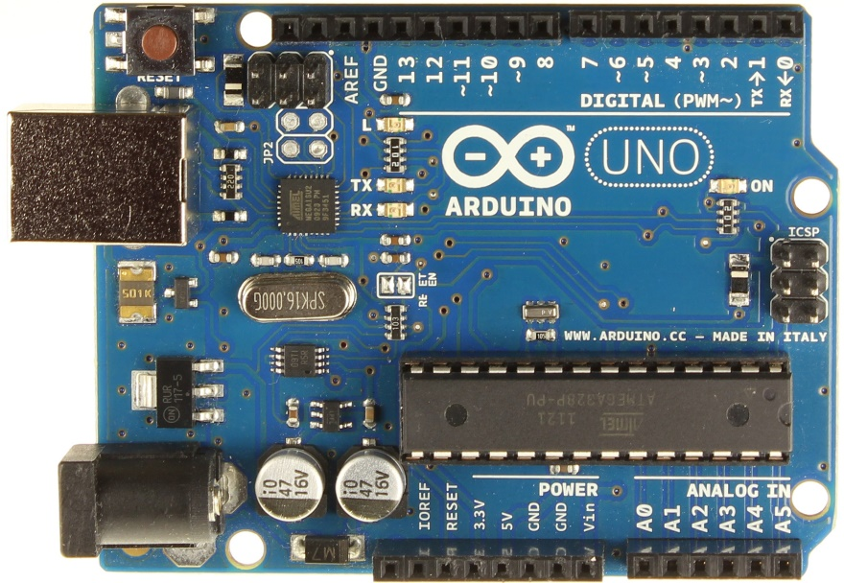
Figure 1: Arduino board.

In the Table 1 follows the timeline assembled by the students of the discipline responsable.

Table 1: Programmed contents.
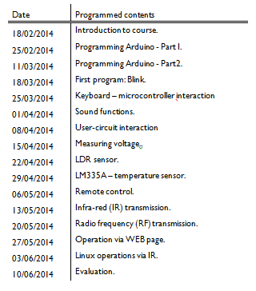
Besides the promised coordination, the group also developed more practical and spent in the classroom.

The teaching the students used to teach the lesson was given to observe how teachers discipline of laboratory and acted as the students wanted it to be. Thus, it was agreed that the first class would be an introduction to microcontroller and lessons applied to ATMega328 programming. Each of the practices discussed in class will be explained briefly below.

Acender LED (LED lights)

This was chosen for the first class of the course practice. For the first counted the student with the Arduino simplest practices so that the student caught intimacy with the language and the platform gradually been chosen.
The circuit for this uses an LED and a resistor. The same is set by the student himself and concepts on how to perform the reading of the bar code resistor and the polarization of the LEDs is passed.
After this understanding is passed notions of C programming language geared specifically to the microcontroller and the practice in question. They are then taught the programming structure, the operation of the IDE and language functions like pinMode (pin, mode), delay (time) and digitalWrite (pin, value). From these statements the student can complete the practice.

Interação entre o teclado e o microcontrolador. Uso da Serial Monitor
(Keyboard - microcontroller interaction)

The Arduino platform has in its composition a USB / Serial converter that allows iteration microcontroller with a host computer. Using this interface the student can send data to the microcontroller or even read data.
The iteration take place by using a tool present in the Arduino called IDE Serial Monitor. It allows viewing and sending of data by the user via the RS232 serial port.
Exploring this tool to practice interaction keypad - allows the microcontroller to trigger leds student present in the external circuit the platform sending data to the Serial Monitor. To this are passed to the student knowledge of the functions used as Serial.begin (), Serial.read () and Serial.flush (). Concepts and instructions in the previous class are also used.

Uso de funções sonoras (sound functions)

The practical use of sound functions introduces students to sound functions present in microcontroller programming and electronic component buzzer. The same is present in many computer boards or via alarm circuits to effect sound to warn the user that something is happening. Functions such as Tone (pin, freq) and noTone (pin), notions of use of buzzer and musical notes are passed to students. Students riding the circuit and program presented the platform in order to deliver basic musical notes and later practice schedule as a piece of music that pleases them.

Display LCD 16X2 (Display LCD 16X2)

The LCD display 16X2 is of great service in a large number of projects. He is nothing more than an interface where you can view messages, or sensor values ​​read any data sent by the Arduino. Thus it does not take a host computer with the Serial Monitor triggered to display these types of data, reducing costs and providing practicality in various projects. This class is explained throughout the schematic connection of the LCD with the Arduino and instructions of their programming using LiquidCrystal.h library.

Leitura de tensão (Measuring voltage)
The voltage reading is the use of Analog.read (pin) function. The function allows you to read voltage levels from 0-5V present in one of the microcontroller pins. For the reading to be taken is necessary to use a six analog pins platform.
They are connected to an A \ D (Analog \ Digital) converter which converts the analog voltage level that is between a level 0 to 5v digital voltage potential between 0 to 1023. Each digital level corresponds to the level of 0.0048 volt analog voltage. This process is called quantization and is used in scanning signals.
To illustrate the process a pot, which is nothing but a variable resistance, is present in the circulation circuit. So that when the resistance of the potentiometer varies varies the voltage read by the microcontroller. Thus the student can see the process happening.

Leitura de sensor de luminosidade LDR (LDR sensor)
The light sensor is a variable resistor LDR which varies with the amount of light incident on the sensor. The more light falls on the same lower your resistance. The physical effect can be availed in various designs. One that we can mention is the photocell. Widely used in streetlights it consists in using the light sensor to identify when there is need that the light is illuminated. In the case when day light is not triggered by the circuit and after dark the same is thrown. Reading practice of LDR light sensor also exploits this effect. Taking concepts learned in previous classes the student drives a present in the external circuit mounted the platform led by the student by varying the strength of the light sensor. Thus simulating what happens in a real design as the photocell.

Leitura de sensor de temperatura LM335A
(LM335A temperature sensor)

The LM335A sensor is a temperature sensor which varies the output voltage according to the temperature reading. As explained in previous practices Arduino can read analog voltage values ​​through their analog pins converter using the A/D (analog to digital). The sensor has a range of output voltage 10mV per degree kelvin. Making an analogy can elaborate a little calculation to be scheduled on the platform, to read that temperature and write it in the Serial Monitor in different temperature scales like Celsius and Fahrenheit. Explain to students throughout the operation of the sensor as the calculations used to the temperature reading. At the end of practice the student is asked to draw up a code so that given a certain temperature the activation of a buzzer to indicate a hazardous situation occurs.

Controle remoto (IR) (Remote control)

IR remote controls are widely used to control television. But why not also use them to drive other devices such as fans or light bulbs?
In this practice, students are instructed on how to identify the code of each key of an infrared remote control with an IR remote control sensor. They have to use a reading script on Arduino platform and annote the codes to be used. Later more the students use these codes to drive LEDs or buzzers in the way that suits them simulating a circuit of actual control.
In practice passage are taught the use of NCIRrcv.h library, the operation of the infrared transmission, sensor operation and as programming platform is made.

Transmissão via IR
(Infra-red transmission)
It uses a pair of infrared emitter and receiver for transmitting and receiving data. IR transmission project in an alarm circuit is implemented. These circuits can be used in garage doors for example. On the left side of the gate settles an IR emitter and a receiver on the other side IR. At the time the gate is open and the sensors are triggered maintains the gate in the open state. From the moment the car begins to pass through the gate of the receiver to receive the message and identifies the obstacle closing the gate after the return of the transmission when the car has passed through the gate. In class the students simulate this effect using sensors and replacing the gate driving a buzzer. Again previously learned functions are used in new projects keeping learning in constant use.

Transmissão via radiofrequência (RF)
(Radio frequency transmission)
The radio frequency transmitters are abundantly used in control and automation design and information exchange. We often wonder how we managed to open an automatic garage door with a remote control and this is one of several applications found that transmitters for RF components and receivers.
This practice aims to taught students how to use 433MHz RF transmitters and receivers for data transmission. To this are used two Arduinos and a pair of transmitter and receiver. An Arduino is in charge of transmitting data and other receivables. Data is written via Serial Monitor in Arduino host computer where the transmitter is connected to receive the message and the receiver interprets and acts arduino somehow. In practice concerned LEDs are lit when a certain message is sent. In this class are passed knowledge of data transmission and libraries used in microcontroller programming.

Acionamento via página WEB
(Operation via WEB page)
This project uses an Internet Shield for the Arduino can communicate with the internet. Shields are attached to the Arduino platform that can add new features to it. Students in this practice, you can see an example of the automation design using microcontroller. An HTML page is scheduled on the platform and can be accessed through a pre-programmed IP. On this page are buttons that can activate when selected lamps, LED and cooler which are present in the Arduino external circuits. Simulating real loads that can be activated at a distance via the Internet. For this knowledge of HTML programming, PHP, electronics and programming controller itself using libraries SPI.he Ethernet.H are passed. Students assemble the project and as a final challenge are instructed to program a page that beyond these features show reading a particular sensor as the temperature for example.

Acionamento de operações no Linux via IR
(Linux operations via IR)
Identified the need for a slide presenter for group presentations. Given this need to drive project operations on Linux via IR was prepared. Using the same design remote control. Using Infrared Libraries (IR) identifies keys on the remote control to be used. After identifying the keys a little Python code is written in the Arduino host computer that will act as presenter. This code in Python interprets a message sent by the Arduino and triggers operations on the Linux operating system, for example, to advance or rewind slides. You can also make the drive a video or song forward or back to music. The taste of the user who programmed the system.
The operation of it is explained to the students as well as the programming is done in Python. So they implement the project in class and have a first contact with another programming language in addition to being building something real and functionality can be implemented.

Avaliação
(Evaluation)

The assessment in the discipline consists of two notes. One is the average of the reports to be completed by students for each class. Each has a past practice report covering the content covered and serve as study material pro student. The average worth of reports up to sixty percent of the final grade. The other forty percent of the final grade shall be the last review, the final.
The final evaluation of the course is an entirely practical exam where students demonstrate content absorbed. The proof is based on the objective of the elective in which students learn important concepts in small projects so that they could at the end of the course up a larger, more complex project. Consisting of a matter in which it is present a project to be assembled by a group of students. As said the project is nothing more than any real need identified by teachers and covering the content covered.

- Conclusion
To date, the elective course is ongoing. Nine lessons took place and students have praised rather chosen to minister discipline form. Due to the high demand, the students decided to continue with the elective in the following period.
The fact that the group teach the classes in a lab that was in disrepair, and seen the efforts made by the authors of this article on organizing, cleaning, purchasing new equipments such as air conditioning equipment, blackboard and Arduino kits, it can be said that the Telecom Engineering Department, and hence the University, won a new laboratory.

The authors believe they have achieved a great achievement for both his academic and professional life, acquiring knowledge when preparing lessons, planning is, perform in public, produce educational materials, among others.

Without forgetting one of the objectives of the Program, which students are embedded, which seeks the insertion graduation is transmitting knowledge through classes as seeking to improve the infrastructure of the University.

IV. References
ARDUINO. Referencia oficial. Disponible en: http://arduino.cc/ Visitada el: 10 marzo, 2014.
OXER, Jonathan; BLEMINGS, Hugh. Pratical Arduino: Cool Projects for Open Source Hardware. ed. New York: Springer, 2009. 445 p, il.
CELES, Waldemar; CERQUEIRA, Renato ; RANGEL, José Lucas. Introdução a Estruturas de Dados. Editora Campus, 2004. 294 p, il.

VI. Curricular summary authors
Full name: Roberto Brauer Di Renna
Profession of origin (BA): Telecommunications Engineering
Institution: Universidade Federal Fluminense
Maximum Degree of Education: High School
Telephone: +55 (21) 2629-5606 + + ( 21) 99510-0345
Email: robertobrauer@telecom.uff.br
Brief biographical sketch
Joined the Universidade Federal Fluminense in 2011 in Telecommunications Engineering undergraduate course. In the second period of the course, he was admitted to the Programa de Educação Tutorial - Telecomunicações (Education Tutorial - Telecommunications), where he had the opportunity to learn new programming languages​, develop speaking, actively participate in the University. Responsible for short courses of LaTeX and Arduino Workshop, reaches this moment responsible for the elective course "Tópicos Especiais em Eletrônica II" (Special Topics in Electronics II). Mature GETESB IT company, responsible for assisting in the design of the telemetry, database and networks.

Full name: Thiago Elias Bitencourt Cunha
Profession of origin (BA): Telecommunications Engineering
Institution: Universidade Federal Fluminense
Maximum Degree of Education: Technical Education in electronic media
Specialty: Electronics
Institution: Federal Education Celso Suckow da Cento Tenológica Fonseca (CEFET -RJ)
Telephone: +55 (21) 2627-2979 + + ( 21) 9975167648
Email: thiagobitencourt@id.uff.br
Brief biographical sketch
Electronics technician trained by the Federal Education Celso Suckow da Cento Tenológica Fonseca (CEFET -RJ). He joined the Federal Fluminense University in 2012 in Telecommunications Engineering undergraduate course. In the second period of the course, he was admitted to the Education Program Tutorial - Telecommunications, where he had the opportunity to learn new programming languages​​, develop speaking, actively participate in the University. Responsible for Arduino Workshop, reaches this moment responsible for the elective course Special Topics in Electronics II.

Full name: Alexandre Santos de la Vega
Profession of origin (BA): Electronic Engineering
Institution: Universidade Federal do Rio de Janeiro (UFRJ
Maximum Degree of Education: D.Sc.
Telephone: +55 (21) 2629-5606
Email: delavega@telecom.uff.br
Brief biographical sketch
Alexandre Santos de la Vega was born in Rio de Janeiro, Brazil. He received the B.Sc. degree from the Universidade Federal do Rio de Janeiro (UFRJ) in 1986, the M.Sc. degree from COPPE/UFRJ in 1991, and the D.Sc. degree from COPPE/UFRJ, in 1999, all in electrical engineering. From 1991 to 1993, he has been with the Forward RICH Detector Group, DELPHI Experiment, at Organisation Européenne pour la Recherche Nucléaire (CERN). From 1993 to 1995, he has been with the Department of Computer Science at the Escola Técnica Federal de Campos (ETFC). Since 1995, he has been with the undergraduate Department of Telecommunications Engineering (TET) at the Universidade Federal Fluminense (UFF). His teaching and research interests are in analog and digital signal processing, electronic circuits and adaptive signal processing.

